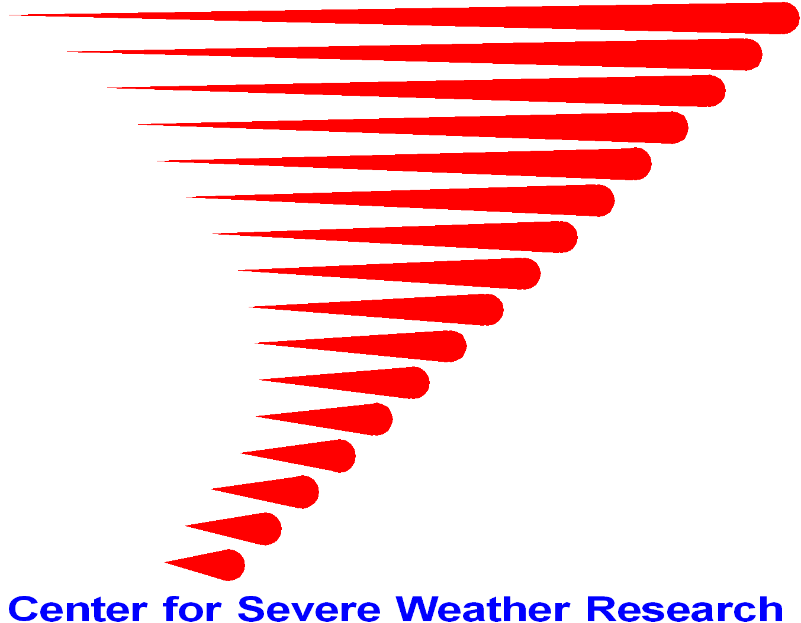
Request for CSWR DOW Facility Support
Center for Severe Weather Research
1945 Vassar Circle, Boulder, Colorado, USA
720-304-9100 admin@cswr.org

Version 2017-0428a

We urge that you contact CSWR before submitting this form to discuss your DOW Facility request

Please answer each question using Red font. Multi-line responses are okay.

Instrument | Requested (Yes/No) | Number Requested
DOW6 (dual-pol, dual-freq)
DOW7 (dual-pol, dual-freq)
DOW8 (single beam)
DOW8 (rapid-scan 6 beam)
Mobile Mesonets
Deployable Surface Stations
Upsonde Expendables

A. User Information

- Lead Requester:
- Affiliation:
- Contact Information:
- Address:
- Email:
- Phone:
- Other Requestors and Affiliations and Contact Information

- Previous experience with similar instrumentation

- Selected publications using similar instrumentation

B. General Project Information

- Name of Project:

- Dates of Field Program:

- Dates of Requested Deployment of CSWR DOW Facility instrumentation:

- Location of Field Program:

- Is the field program nomadic or does it have a fixed base (if fixed base, location?):

- Funding Agency for Requested Deployment:

- Brief (one paragraph) description of Field Program

- Brief summary of what other observational systems will be used in the project

- Please attach here, or to the general LAOF request, the written description of the project, usually the NSF or other agency Project description (15 pages), and/or the SPO/EDO or links to these documents.

C. Specific Request Information

- Radar (DOW) Request
- Number of DOWs:
- Rapid-Scan multi-beam capabilities?
- Dual-Polarization capabilities? If yes, how many DOWs need this capability?
- Real-Time data request? Describe.
- Number of IOPs.

- Duration of IOPs.

- Describe spacing of IOPs, frequencies, and plans for days off, etc.
- Narrative paragraph(s) describing how DOWs will be used. Describe the specifics of the deployments. (Will the same site for project duration? Different pre-scouted sites? How many pre-scouted sites need to be chosen? Will redeployments occur during IOPs? Will sites be found on an ad hoc basis (“chasing mode”)?)
- Will PIs provide assistance in locating pre-scouted sites? Describe.
- Is a CSWR site survey requested?
- Travel duration/distance by DOW vehicles each IOP.
- Travel/commuting duration/distance by DOW crews each IOP.
- Any remote, challenging or unusual siting? Hot, cold, windy, or any other environmental or other extremes? Unusual security needs or arrangements? Unusual access issues?
- Radar Parameters. Different DOWs have different capabilities; some differences are major, some minor. In the following categories, indicate if the requests apply to one or more DOWs, and whether they are exact or approximate requests.

If no specific request/requirement, or if unknown, or not understood, then just leave blank or “N/A”. Also, please contact CSWR and ask.

- Volumetric update rate (or sync interval for multiple-Doppler):
- Scan rate:
- Number of scans/tilts/sweeps per volume:
- Range gate resolution (typical values range from 25m – 100m):
- Spatial volumetric request raw and/or multiple-Doppler (e.g. 100x100x100 m):
- Specific radar products requested (typical products include, V, dBZ, ZDR, etc.)
- Multiple-Doppler products (e.g. u,v,w Synthesized Cartesian-gridded winds) requested?
- Is archiving of raw time-series (I,Q) requested? Time-series usually are archived to allow post-project reprocessing to change calibrations, clutter filtering, azimuthal sampling, etc.
- Pulse length request (typical values range from 0.333 – 1 us):
- Sensitivity request. Clear air sensitivity desired out to what range?
- Special calibration requests. Real time?
- PRT/PRF requests. Maximum unambiguous velocity. Staggered or other pulsing schemes requested?

- Maximum Range

- Will scan strategy change during deployments? How will this be decided, communicated, implemented to/by DOW operators?
- Any other special requests for scanning, archiving, processing?
- Other requests relating to DOW vehicles
- Are meteorological observations from the DOW masts requested? Describe request. Standard measurements include T, RH, Wind at ~18 m AGL.
- Special communications requests beyond cell phones and standard DOW VHF radios

- Staffing
- How many staff will project PIs provide? Will these be supported in whole or part by the project PIs? Describe what levels of staffing the PIs will provide.
Substantial cost savings and enhanced educational opportunities flow from PIs providing DOW staffing. DOWs can be operated and driven by students with very little training. Different types of deployments require different numbers of crew in each DOW. Typically, two crew per DOW are required. CSWR will provide training as needed. (Please contact CSWR to discuss staffing.)
- What skill levels are needed for CSWR-provided crew? Do you need meteorologists? Do you need autonomous decision making related to changing scan strategies?

- Do you request a CSWR DOW Deployment Manager in the field to assist with DOW deployments, site selection, etc.?

- Mobile Mesonet (MM) Request

Some of these questions may seem redundant with radar section, but some projects make different plans for different types of instrumentation. You can just respond “same as Radar section”

- Number of Mobile Mesonets requested?
- Real-Time data request? Describe.
- Number of IOPs.
- Duration of IOPs.
- Describe spacing of IOPs, frequencies, plans for days off, etc.
- Narrative paragraph(s) describing how MMs will be used. Describe the specifics of the mesonet transects. If mesonet transects are on unpaved roads or other unusual roads, please elaborate.
- Will the project request a CSWR site survey?
- Estimated travel distance by MMs each IOP.
- Remote or challenging or unusual travel during IOPs? Anticipated road conditions, including traffic hazards, snow, rain, wind or other hazards. Hot, cold, windy, or any other environmental or other extremes. Unusual security needs or arrangements. Unusual access issues?
- Data Request.
- Requested meteorological parameters (e.g., T, RH, P, Wind).
- Update rate of meteorological parameters (standard rate is 1 Hz).
- Non-standard meteorological parameters or collection strategies, including tethered or low-level drone meteorological observations or site photography.
- Upper-air sounding launching capability. If so, do you request CSWR provide the sounding system or just expendables?

- Other special requests for archiving, processing.
- Staffing requirements
- How many staff will project PIs provide? Will these be supported in whole or part by the project PIs? Describe what levels of staffing the PIs will provide. (Substantial cost savings and enhanced educational opportunities flow from PIs providing MM staffing. MMs can be operated and driven by students with very little training. CSWR will provide training as needed. Please contact CSWR to discuss staffing.
- What skill levels are needed for CSWR-provided crew? Do you need meteorologists? Do you need autonomous decision making related to changing transect or other deployment strategies?
- Do you request a MM Deployment Manager in the field to assist with deployments, etc.? Can this person be the same as the Dow Deployment Manager?

- Deployable Instrumentation, POD, Requests (some of these questions may seem redundant with radar and MM sections, but some projects make different plans for different types of instrumentation. You can just respond “same as Radar (or MM) section”
- Number of Deployable Instrument Set (Pods) requested?
- Real-Time data request? Describe.
- Number of IOPs.
- Duration of IOPs. Pods, being unstaffed, can be deployed for prolonged periods, if configured with power, memory, or uplink capability.
- Describe spacing of IOPs, frequencies, plans for days off, etc.
- Narrative paragraph describing how Pods will be used. Provide specifics of deployment strategy descriptive paragraph. Same site for project duration. Different pre-scouted sites. How many pre-scouted sites need to be chosen? Will redeployments occur during IOPs?
- Are Pod deployment vehicles (often MMs) requested to deploy Pods. Depending on Pod configurations, approximately 3-5 Pods can be carried by each MM-style deployment vehicle.
- Will PIs provide assistance in locating pre-scouted sites? Describe.
- Will the project request a CSWR site survey?
- Travel duration/distance by Pod deployment vehicles each IOP.
- Remote or challenging or unusual siting and or travel during IOPs? Anticipated road conditions, including traffic hazards, snow, rain, wind or other hazards. Hot, cold, windy, or any other environmental or other extremes. Unusual security needs or arrangements. Unusual access issues?
- Data Request.
- Requested meteorological parameters (e.g. T, RH, Pressure, Wind, Photo/Video, Disdrometer Particle Size).
- Other special requests for data collection, scanning, archiving, processing.

- Staffing requirements
- How many staff will project PIs provide? Will these be supported in whole or part by the project PIs? Describe what levels of staffing the PIs will provide. (Substantial cost savings and enhanced educational opportunities flow from PIs providing Pod staffing. Pod deployment vehicles can be operated and driven by students with very little training. CSWR will provide training as needed. Please contact CSWR to discuss staffing.
- What skill levels are needed for CSWR-provided crew? Do you need meteorologists? Do you need autonomous decision making related to changing deployment strategies?
- Do you request a Pod Deployment Manager in the field to assist with deployments, site selection, etc.? Can this person be the same as the Dow and/or MM Deployment Manager?

D. Any Additional Requests or Information

